**Ideation Phase**

**Define the Problem Statements**

|  |  |
| --- | --- |
| Date | 19 September 2022 |
| Team ID | PNT2022TMID45340 |
| Project Name | Project – Real-Time Communication System Powered by AI for Specially Abled |
| Maximum Marks | 2 Marks |

**Customer Problem Statement Template:**

Create a problem statement to understand your customer's point of view. The Customer Problem Statement template helps you focus on what matters to create experiences people will love.

A well-articulated customer problem statement allows you and your team to find the ideal solution for the challenges your customers face. Throughout the process, you’ll also be able to empathize with your customers, which helps you better understand how they perceive your product or service.

Reference: <https://miro.com/templates/customer-problem-statement/>

**Example:**

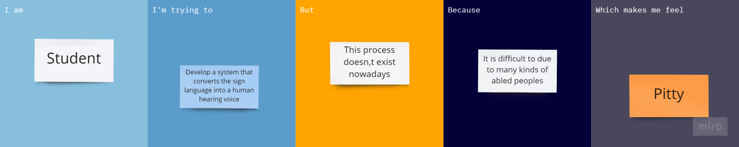

|  |  |  |  |  |  |
| --- | --- | --- | --- | --- | --- |
| **Problem Statement (PS)** | **Iam (Customer)** | **I’m trying to** | **But** | **Because** | **Which makes me feel** |
| PS-1 | a student | Develop a system that converts the sign language into a human hearing voice | this process doesn’t exists nowadays | It is difficult due to many kinds of abled peoples | pitty |
| PS-2 | a abled person | Speak and hear to live in the real world | significant developments are not undertaken | it is difficult for us to receive the message from the normal people | down |